Pricing Analytics – Cambrdige Software

Sriganesh Balamurugan – 11915001

Anmol More – 11915043

Raghu Punnamraju – 11915010

1. If CSC were to offer only one version of Modeler, which version should it offer? At what price?

**Ans:** CSC should offer Industrial version at $100 price. This will maximize their profit to $14.7M

Final Profit = Revenue – Fixed Cost, if version was chosen – Development Costs of segment, if picked – Variable Costs (size* unit variable cost), if picked and sold

Because of the size of the student segment, though the price is less, the profit is maximized

Below is the optimized solution from excel

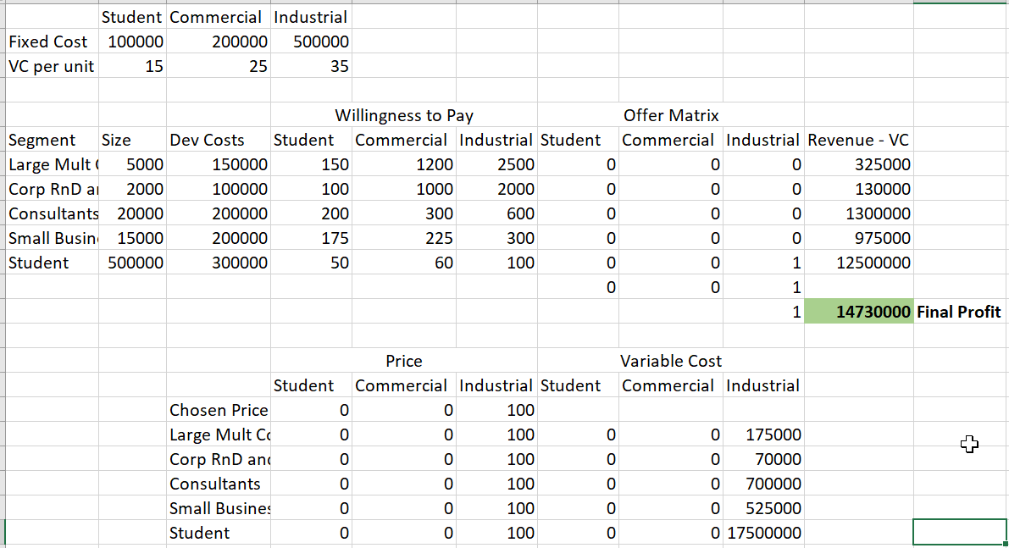

1. How many different versions of the Modeler should CSC offer? At what prices?

**Ans** CSC should offer two versions Industrial at $100 and Commercial at$1200. This will maximize their profit to $20.4M.

Just as above, the size of student segment has influenced the optimization the most. The second influencer was the high price of the commercial version and the size of the Large and multidivisional corporations.

Below is the optimized solution

